**Software engineering**

### Project Proposal

**Report 2**

**12/5/2019**



Team: Shadowrocket

Team Member:

|  |  |
| --- | --- |
| Name | FHSU ID |
| William | 66195207 |
| Chandler | 66088445 |
| Palmer | 23137342 |
| Caden | 84751102 |
| Guy | 84651951 |
| Jay | 49038231 |

Github URL: <https://github.com/Devourd/SIAS-RENTAL-PLATFORM>

Table of Contents

Page Title

Interaction Diagrams………………………………………………………….3

Class Diagram………………………………………………………………..14

System Architecture and System Design……………………………………..20

User Interface Design and Implementation………………………………… ..24

Design of Tests…………………………………………………………………29

Project Management……………………………………………………………31

Task Assignmen…………………………………………………………………35

References……………………………………………………………………….36

Interaction Diagrams

1. Registration

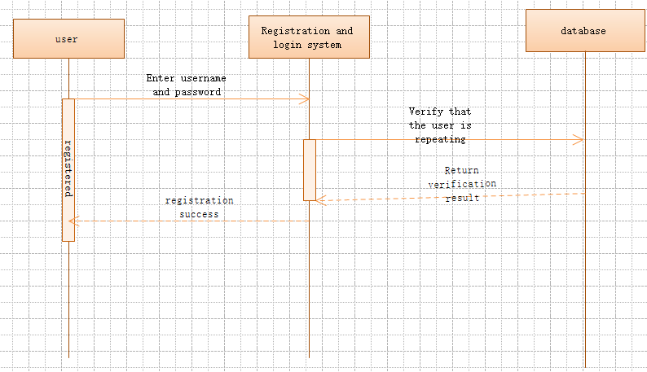

The user selects a favorite user name and sets a password that he or she feels safe. When the user enters the account and password into the registration system, the system feeds back the information to the database for verification to see if there is a duplicate username, if the system If the database user name is not duplicated, the registration is successful.

1. Login / logout

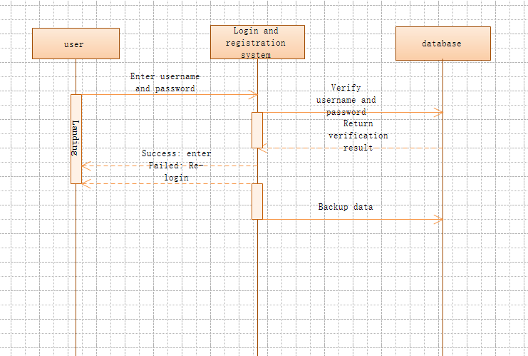

The user enters the user name and password when registering himself, and the login system feeds back the information to the database for verification. The database verification password and the user name are the same as the data stored in the database. If the verification succeeds, the login succeeds. If the verification fails, the login fails, and the account is re-entered. Login with password

1. Maintain personal information

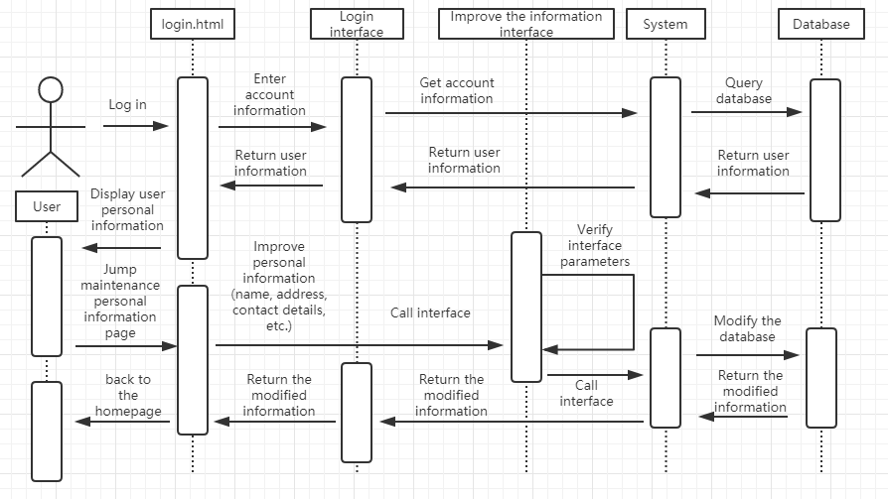

After the user logs in, click the Perfect Personal Information button, and the system will read the stored personal information from the database and display it on the website. Then the user can select the perfect personal information on the corresponding project. After completing the button, the information will be transmitted to the system. If the audit is passed, it will be stored in the database. If the audit fails, the user will refuse to modify and ask the user to re-improve the corresponding information.

1. Upload the product

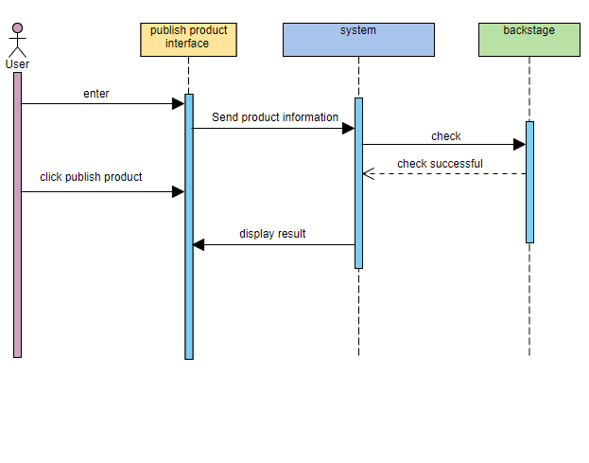

The user enters the publish product interface and sends a publish request to the system. The user clicks to post the product, the product information is uploaded to the system, and the background administrator performs check. Check passed, display the results and feed back to the user

1. Delete the item

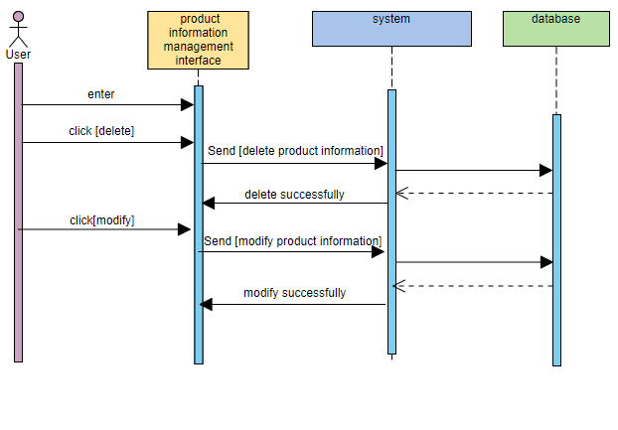

The user enters the product management interface, selects the deleted product and clicks delete. Send the deleted product information to the system, and then query the database. The database feedback information to the system, and finally the product information is deleted successfully. At the same time, we added the function of modifying the product information, and the operation is the same.

1. Search and view products

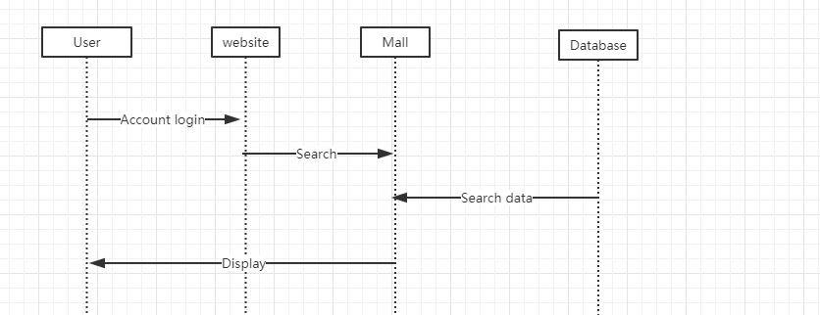

Users need to open the site and log in with their own account. Then go to the mall page to search for the goods you want, and the database will feed back to them the relevant goods that will be on the shelves.

1. Filter items by specific criteria

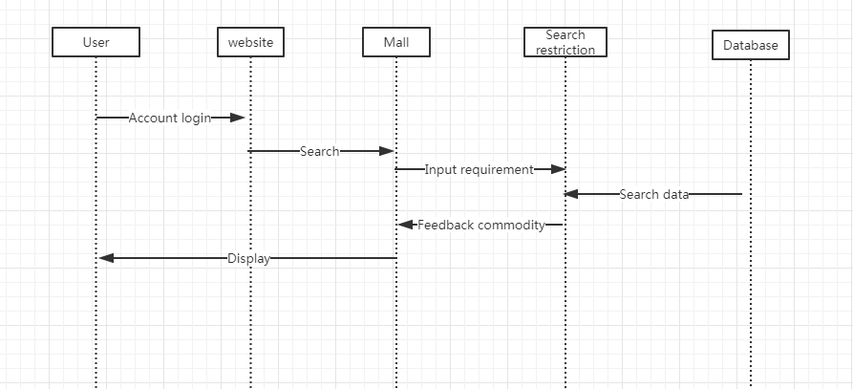

Users open the site to log in with their own account, enter the mall page, search for the goods they need, but also limit the search conditions, such as price and model. After the search in the database, the matching items will be fed back to the user.

1. Shopping cart checkout

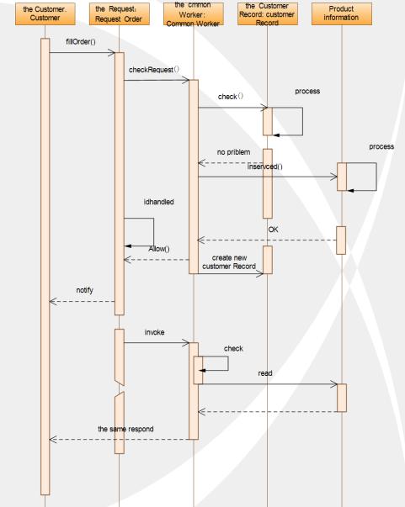

Customers need to rent related products, first customers must find and fill out the relevant rental application form. The back office of the website is responsible for processing the application. Based on the history of the customer's lease and the status of the items leased by the customer, they decide whether to accept the customer's rental application. If both conditions are met, the customer's rental request will be accepted, otherwise they will refuse. The item is leased and the processed application status is set to Processed. If accepting the user's rental needs, the two parties negotiate how to pick up the goods through the website.

1. Full purchase of goods

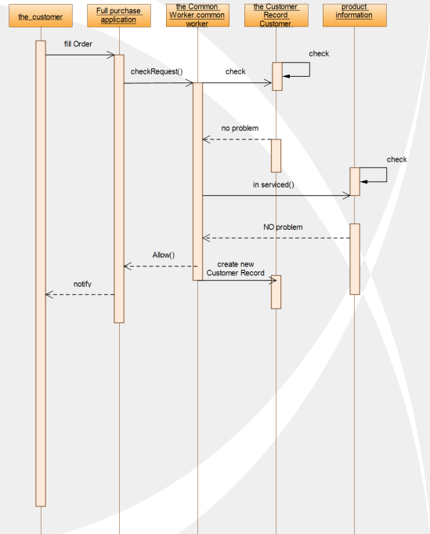

Some customers want to buy out the goods. First, the customer needs to fill out an electronic application form for purchase. The software background administrator is responsible for processing these application forms. The administrator will judge whether the user has credit according to the user's historical rental record, if the conditions are met. Then the request will be allowed, the customer can purchase the permanent right to purchase the full amount. If the background finds that the conditions are not met, the customer's application will be rejected, so the user can not choose the permanent use right purchase option of the product. . When the transaction is successful, the system administrator will add a purchase record instead of a lease record to the user's record.

10. Payment process

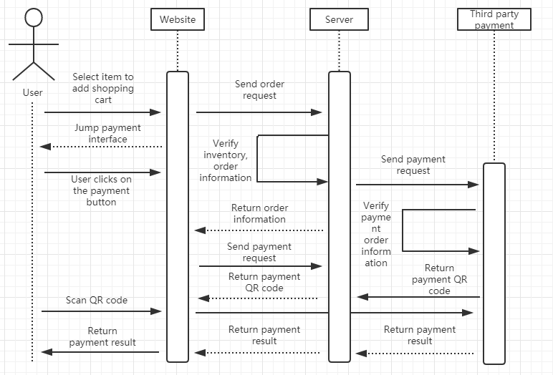

After the user selects the item to be rented, click the rent button to enter the payment interface. This interface will display the product information that the user will purchase, the rental time and the price. After the user confirms, click the confirmation button, and the system will jump into the third-party payment interface (Alipay, WeChat payment) The third-party payment system will then produce a two-dimensional code. After the user scans the mobile phone, the payment is confirmed. The third-party payment system will successfully report the payment to the system. The system will report the payment status to the user through the website.

11. Comments

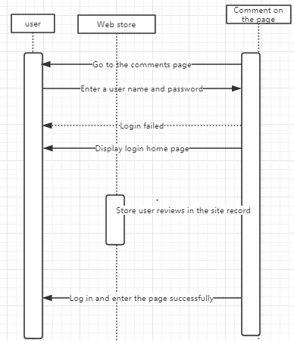

The user enters account number and password, login success goes to main page directly. Click on the comment page and the user can comment. After the comment is successful, the system stores the comment record directly in the website store.

12. View order status

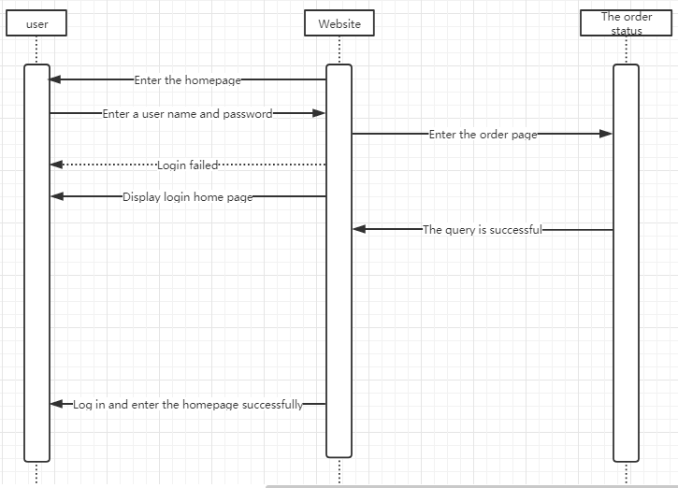

Users login to the website page and click to purchase. View the order status of the purchased item in the purchased item.

**Class Diagram**

Class 1

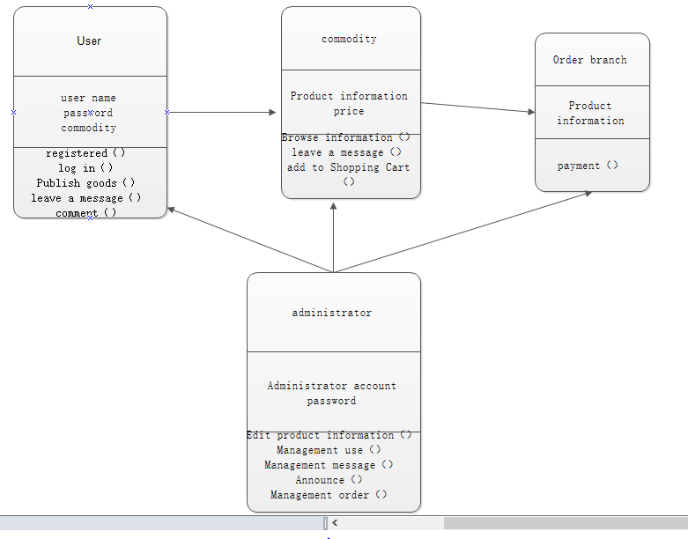

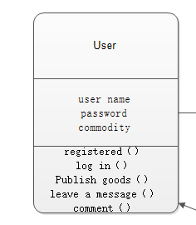

User registration login class:

Attribute: the name selected by the user（user name）, the password set by the user（password）

Method: used to log in（log in） to the website to post products （publish goods）and comments（comment）

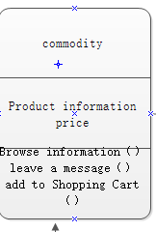

Commodity information class

Attribute: information of the product（product information）, the price at which the product is sold（price）

Method: The user selects his favorite item（browse information）, the user communicates with the seller（leave a message）, and the user joins his shopping cart(add to shopping cart).

Class 2

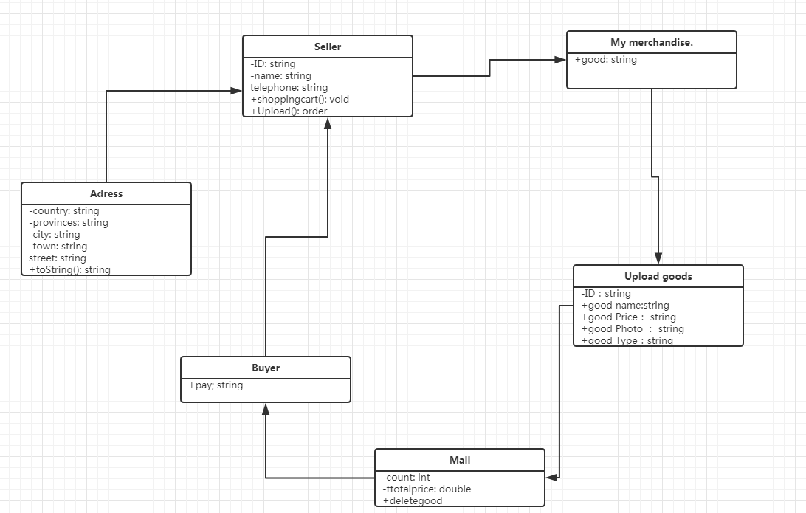

First, define three properties and two methods for the seller, and the user must register before logging in. I define four types of uploaded items that users use to upload their own products. And finally reached the mall's database. For the buyer to search, the buyer finally sends the order to the seller, determines the user's address information through the location class, and generates the order of the leased goods.

Class 3

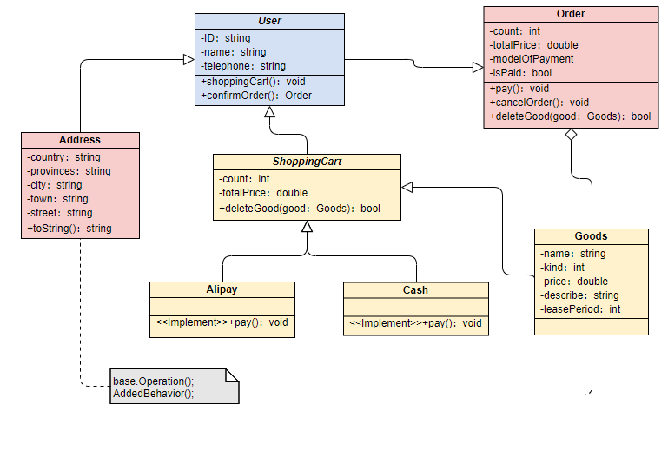

First of all, I define three properties for the User class. The user must register and then log in. I have defined five basic properties for the Goods class. The User class places an order through the Order class, selects the goods of the appropriate rental period, and adds the shopping cart through the ShoppingCart class. Then, the payment method is selected through the Alipay or Cash class, and finally determined by the Adress class. The user's address information, the rental product order is generated successfully,

Class 4

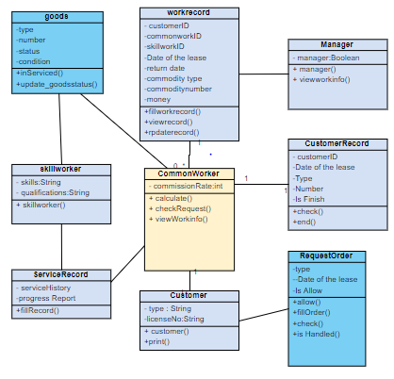

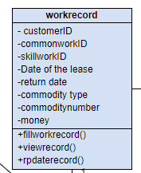

Staff work record class：

Attribute：The customer account（customer ID）, Staff account(commonworkID), Technical account(skillworkID), Date of the lease,return date, Type of item rented(commodity type),number,money

Methods: Fill out this record, View this record, Modify this record

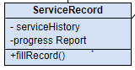

Rental service record class(Records of each rental service)

Attribute: Service history,progress report

Methods: Used to fill in the form(fillrecord())

**System Architecture and System Design**

**Architectural Styles：**

SIAS-RENTAL-PLATFORM uses a Three-tier architecture，this is a is a client-server software architecture pattern :

* The Presentation tier is responsible for presenting information directly to

the user.

* The Middle tier controls website’s functionality by performing detailed processing.
* The data layer includes website operation data, product data, and user personal data.

**Using Three-tier architecture has the following advantages :**

* The processing of the data is completely completed on the server, which greatly reduces the processing load of the user equipment.
* Since the data is stored on the server and the security is improved, the user only needs to receive the processing result, which reduces the occurrence of data leakage.
* Easy background service upgrade, based on the website interface, avoids

the user experience of frequently upgrading software.

**Mapping Subsystems to Hardware**

During the operation of the SIAS-RENTAL-PLATFORM, all collected data will be stored in the database on the server. The server will be hosted on the cloud host platform, when the user accesses the server using the client, the client opens a TCP/UDP socket to access and communicate the server.

**Persistent Data Storage**

The system needs to save website operation data, product data, and user personal data

during continuous operation. Because these data will occupy a large amount of volume, they will be analyzed and indexed in the server, after use only need to send the results to the client.

**Network Protocol**

HTTP protocol must be used in order to make " SIAS-RENTAL-PLATFORM " interact with server and client. At the same time, we will introduce the "Alipay" API access to third-party payment systems for payment functions. We will open the IPC socket connection so that the server can interact with the database.

**Global Control Flow**

Execution orderness: In the " SIAS-RENTAL-PLATFORM ", only the user interface is event-driven, and everything else is program-driven.

Time dependency: The SIAS-RENTAL-PLATFORM is a real-time program.

When the user initiates a request, the system will begin processing user-initiated requests. When the user stops responding, the system will respond to the Timer and every half hour collect and parse data after waking up.

Concurrency: We will use single thread in the user interface and data.

**Hardware Requirements**

Display Super VGA (1024*768) or higher resolution display (color setting is 32- bit true color)

Browser based on IE 6.0 or Chrome kernel

The user's minimum bandwidth is 56 Kbps At least 2GB of storage

User Interface Design and Implementation

When we created our own rental platform website, our first consideration was to investigate several transaction websites that are currently relatively popular in China. We need to learn and absorb the unique advantages of other websites. Ease of use is an important feature when users identify websites. We first designed an easy-to-observe logo for the site. 

When we designed the logo, the first thing that came to mind was the need to create a search box that would allow users to easily search for things they wanted. The search box also makes recommendations based on your search history.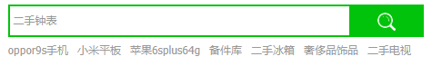

At the same time, we also consider that it is a disaster for users to search for the products they need in the disordered and disordered product pages. So we classified all the goods. In this way, users can easily search for what they need. 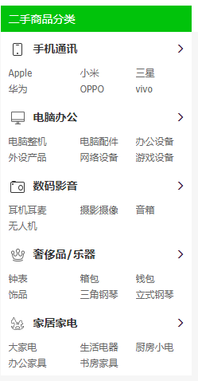

**Make assumptions about users who use this page:**

Users who use the rental web page are defined as users with basic computer operations and related basic e-commerce knowledge. The rental web interface that the user wants to use conforms to the Windows system, so the user interface designed must be suitable for each version of Windows Web. Since the user is most likely to use the product when it is urgently needed, the user has relatively high requirements for easy-to-operate features and user interface comprehensibility. These requirements also reduce the time consuming situation in development.

**Team changed to user interface:**

Since the previous user interface design did not take into account the intuitiveness of the user interface, it was decided to adopt a novel and colorful user interface in the design, which means it can attract more users. However, the original design concept has sacrificed some content. The intuitiveness that users need when using this software. Ignoring too complicated operations may be less friendly to some users. As a result, the team made changes after learning about some bugs and modifying complex operations and features that were not very useful in the user interface. Strive to achieve the most intuitive and simple operation.

**User interface design principles**

The computer side campus rental web user interface is designed to follow a user interface where text and images coexist. This design approach makes the combination of images and text look unmonotonous and intuitive. When a user first uses text and images, the user may need some time to understand the role of text and images in the user interface, but these uses do not take much of the time.

In the interface design, you should know that the user's operation on the web page is the core content of the user interface. In the user action section, possible conflicts should be avoided as much as possible, but for simple cases, smart actions should be used to minimize user actions. Reduce the user's operational burden, such as the automatic login function after the user logs in once. However, some content needs to be determined by the user to determine the working direction and content of the interface. For example, whether to confirm the purchase, the relevant instructions for the lease, and the number of days to choose the full lease or purchase.

**User interface language and text consistency**

The text in the user interface and the pictures of related operations should have some consistency, which prevents the user from having some visual differences in viewing the user interface and operating the user interface, resulting in some operational complexity. Programs in the operating system should also have some consistency in the operation of the user interface.

**User interface layout consistency**

In the user interface, the layout should be rationalized. There should be no complicated and cumbersome situations in the layout. When the user logs in, the username and password must be displayed in the middle of the large font. When the user needs it, the user should be reminded to register the user and change the password. Minimize the font size and reduce the font when the color is not needed, and hide it as much as possible. . All operations of the user in the operation should be consistent.

**User interface program response time and solution**

Some programs may respond slowly when a user operates a rental website user interface. When these conditions occur, the product's user interface must have some feedback to prevent the user from knowing the progress of the site while waiting. However, the same website user interface wait condition settings must be compatible with the user's PC and other operating systems.

**The function processing response time length icon displayed while waiting for the interface**

List of related wait modes:

|  |  |
| --- | --- |
| Functional process response time length | Icon that appears when waiting for the interface |
| 0 second — 5 second | QQ截图20190427164421 |
| 5 second — 10 second | QQ截图20190427164502 |
| 10second the above | The word "Try again" appears, the user refreshes the interface after clicking |

**Provide relevant suggestions and comments**

There is a suggestion and complaint identifier at the location of the user interface checkout. Users can use this logo to feedback the problems that arise when using the user interface. Our team will also analyze and get useful suggestions, and finally optimize the user interface. And modified.

**Design of Tests**

The web-based SIAS-RENTAL-PLATFORM has the flexibility to operate on multiple different platforms. Therefore, we have chosen to test on three operating systems of PC (Windows, MacOS and Linux), Android and IOS, and we believe this will cover the vast majority of user groups.

The detailed test conditions are as follows:

PC (Windows, MacOS and Linux): Use IE 6.0 and Chrome53.

Android: Use UC Browser and Chrome Browser on Android 6.0 or above.

IOS: Use UC Browser and Chrome Browser on IOS 9.0 and above.

In the actual test, we will select different products and test them simultaneously on three platforms to maximize the simulation system to cope with the effects of many complex conditions.

We will enter the following conditions:

* Register a personal account: William
* Upload product: SLR camera
* Uploading price: 25/h
* Upload corresponding image
* Record upload time

Then we will go to the website and compare the following data:

* Upload Account Name: William
* Product Name: SLR camera
* Product price: 25¥/h
* Check if the product image corresponds
* Check if the upload time corresponds
* Make payment and return to confirm that the payment status is successful

This test will be conducted every four hours for 24 hours.

If the website data is fully consistent with the test data, then the system can be considered to be able to achieve the expected functionality through testing.

Project Management

**Team management and preliminary planning：**

We have established a scientific and efficient management model for the operation of the Sias leasing platform. In the initial stage of the website camp, the team consisted of 5 people, including Caden, a technical back office, information editing department, and finance department and marketing according to their functional needs and their own advantages. Internally, we will discuss the personnel, invite relevant students and teachers to communicate, and improve the overall quality of the entire group. We recruit talented people from outside, and participate in the recruitment of people inside and outside the school. In terms of personnel distribution, the overall quality of the training team, mutual help and mutual assistance, assigning corresponding work according to their abilities and personality, and conducting exchange activities every week to talk about harvesting experience. Start a weekly innovation conference and bring innovation to our team. We have strict requirements on the quality of the work done by the team members, and aim to provide the best service for the students with the maximum limit.

Our early work plan has a linear progression that breaks down the entire project into several parts. Then assigned to each group member. We hope that every part of the project will be completed smoothly

Our first part has been completed. At the beginning of the project, we have made a clear division of work for the entire work plan, and we have made specific requirements for the date of completion of the work, so as to ensure the completion of the project. Below we use the Gantt chart to show the work plan of project one. 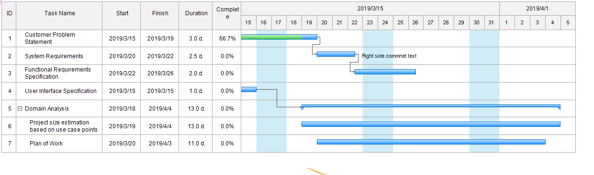

At the same time, we also made a plan Gantt chart of the whole project to ensure that we have a clear understanding of the whole project. We will clearly indicate the time and end time of the project in the figure. 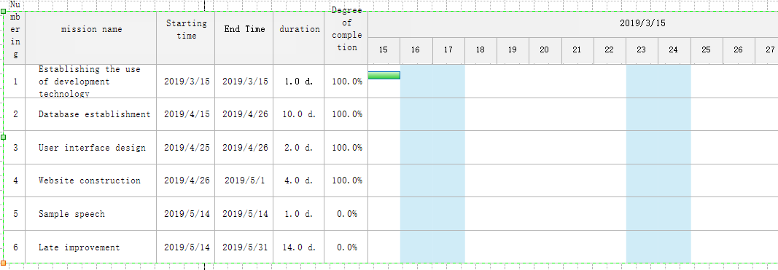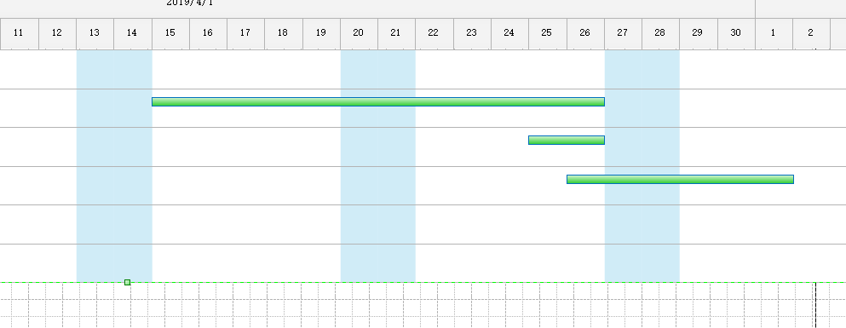

In the early stage, our development focus was on the website, but with the continuous development of mobile devices, our users may have demand for mobile phones. We will continue to investigate user needs and make new improvements according to market needs. Once our website is built, we may test it, correct the problems we find, and discover some of the features that we have found that we don't have, and add new features.

For our current shopping software, we will do a lot of work in the future to improve and optimize the software to provide better service to users. Large item information is a prerequisite for ensuring traffic to the shopping platform, so it is important to expand the user base. Vigorously promote our item trading platform to allow more people to register and publish items. We can push the item information according to the user's past shopping, let the user feel the intimate service, remind the user to have their favorite items on the shelves. In order to maintain a large flow of the platform, we must ensure that the user's shopping is comfortable. So we have some feedback on the problems caused by the software for some customers shopping, and timely improvement

Task Assignmen

|  |  |  |  |  |  |  |  |
| --- | --- | --- | --- | --- | --- | --- | --- |
| Team Name: Shadowrocket | | William | Chandler | Palme | Caden | Guy | Jay |
| Responsi bility levels | Interaction Diagrams | No.3, No.10 | No.8  No.9 | No.1 No.2 | No.4No.5 | No.11  No.12 | No.4 No.5 |
| Class Diagram  Members |  |  | Class1 | Class3 | Class4 | Class2 |
| System Architecture | **√** |  |  |  |  |  |
| User Interface Design and |  | **√** |  |  | **√** |  |
| Design of Tests | **√** |  |  |  |  |  |
| Project Management |  |  | **√** | **√** |  |  |
| References | **√** | **√** | **√** | **√** | **√** | **√** |

References

Java <https://www.w3cschool.cn/>

Java <https://www.runoob.com/>

<https://www.oracle.com/technetwork/java/javase/downloads/index.html>

SQL server <https://www.microsoft.com/zh-cn/sql-server/sql-server-downloads>

Drawing tool <https://www.processon.com/diagrams/new#template>

Tomcat <http://tomcat.apache.org/>